

Interview Test App

Web API



October 29, 2022

Shoaib Ijaz

Contents

Document Scope 2

System Environment 2

Authentication and Authorization 2

Design Approach 2

Solution Structure 3

Database Design & Tables 3

Table - AspNetUsers 4

REST API Endpoints – Request & Response 4

Default Login Details 4

# Document Scope

This document provides a description of the technical details REST API and Database. This document provides an architectural overview of the system to depict different aspects of the system.

# System Environment

|  |  |
| --- | --- |
| **Rest API** | ASP.NET Core 6.0, C# |
| **Database** | MSSQL Local DB |
| **Unit Test** | .NET Core, C#, XUnit |
| **Development IDE** | VS Studio 2022 Community 64-bit |
| **Development OS** | Windows 10 |
| **Version Control** | Git, Github.com |
| **Web Server** | IIS |

# Authentication and Authorization

This application is using the **ASP.NET Core Identity** for membership system and manages users, passwords, profile data, roles, claims and tokens.

Rest API End-Points authenticate the user via JWT (**JSON Web Token)** scheme**.**

# Design Approach

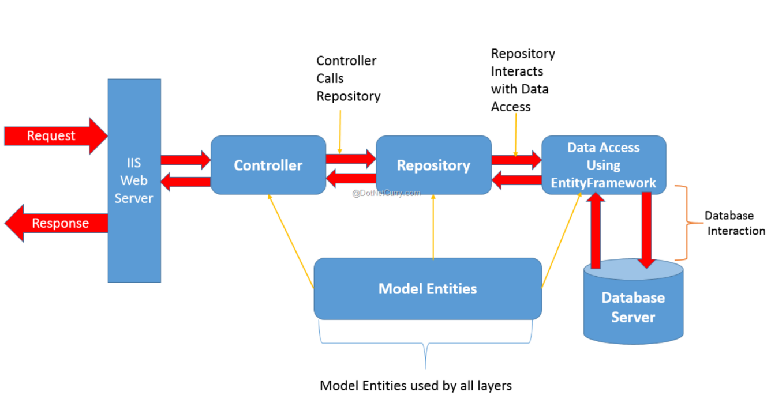This application is developed with **Repository Pattern** approach.

# Solution Structure

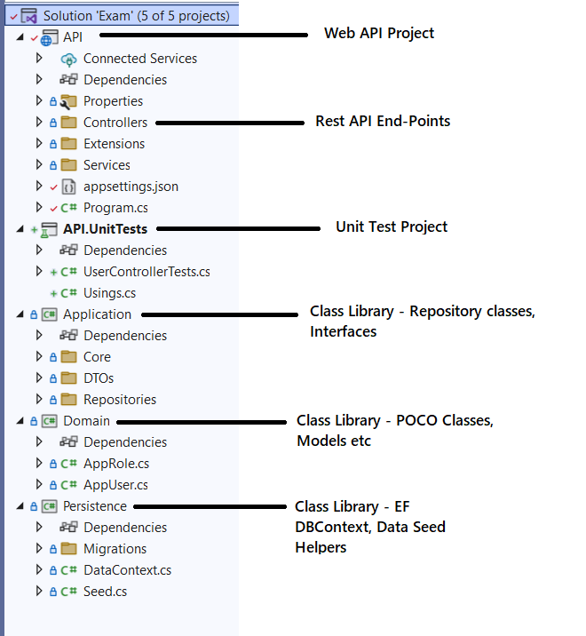

# Database Design & Tables

The major database table is **AspNetUsers** that is mapped with Entity-Framework model AppUser (Domain Class Library)

## Table - AspNetUsers

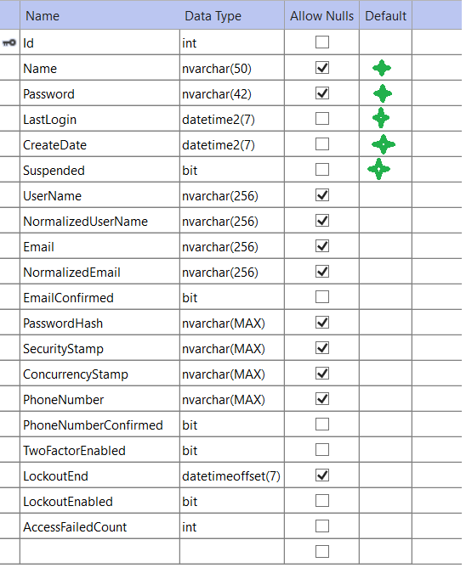

# REST API Endpoints – Request & Response

API documentation has been provided in separate document

# Default Login Details

{

  "password": "Pa$$w0rd",

  "email":"bob@test.com"

}

Website URL: <http://pixel.somee.com/>